What my Splash Screen looks like for me

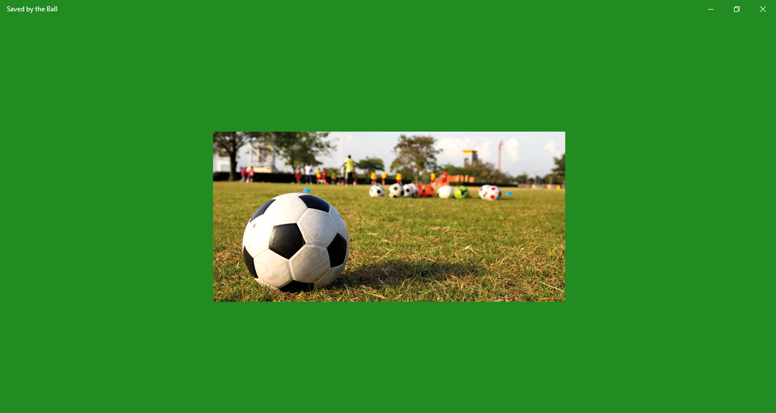

Message I sent to GitHub support

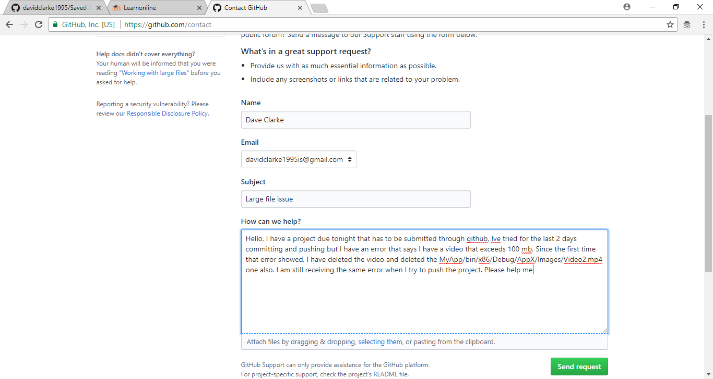

Error message that stopped me from continuing my project for the last week and ultimately ended my app untimely.

